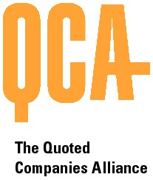

THE QUOTED COMPANIES ALLIANCE
SHARE SCHEMES COMMITTEE
PROPOSED MEETING DATES FOR 2012

All at 5.30pm unless otherwise advised (approx every 3 months)

Thursday 9 February 2012

Thursday 24 May 2012

Thursday 6 September 2012

Thursday 6 December 2012

